AREC 213 Midterm I Exam

Student Name______________________________________________________
Instructions for Exam
- This will be due Wednesday, October 30 at the start of class (10 am)
- There are 15 multiple choice questions, 10 true/false questions, 5 short answer, and 2 essay questions
- Show all your Work on Short Answer and Essay Questions for Full Credit
- The scoring for each question type is listed below
  - Multiple Choice- 15 Questions, 3 points each for total of 45 Points
  - True False- 10 Total, 3 points each for total of 30 Points
  - Short Answer- 5 Total, 10 points each for a total 50 Points
  - Essay 1: Porter’s Five Forces- 25 Points
  - Essay 2: Sandwich Costing- 50 Points

True/False
Indicate whether the statement is true or false.

____ 1. Online payment gateways only charge you a service fee after a certain level of income has been reached.

____ 2. To conduct a break even analysis for a sole proprietorship you only need your fixed costs because variable costs are only needed if you are preparing a break even analysis for a public firm that is regulated by the SEC.

____ 3. A General Partnership is required by law to have a board of advisors

____ 4. If you are going to start selling homemade art at local festivals the easiest business to set up would be a Subchapter P Corporation designed for single business owners.

____ 5. A market segment refers to the stage the market is in which usually includes emerging, growth, mature and declining

____ 6. The terms market and industry can be used interchangeably

____ 7. If you run an organic farm your business profitability will be affected by the organic farming industry (Industry Level Factors) and also how you run your business (Firm Level Factors)

____ 8. Your Gross Profit is equal to what you sell times the price of what you sell

____ 9. Even though they are called variable costs these costs are actually fairly fixed because they include things like rent and utilities and any other cost that is not related to direct labor or materials.

____ 10. A C Corporation experiences double taxation but is not taxed as a separate entity

Multiple Choice
Identify the choice that best completes the statement or answers the question.

____ 11. A(n) ________ is a group of firms producing a similar product or service, such as soft drinks, electronic games, or computers.
a. | Sector | d. | Network
b. | Industry | e. | Market
c. | Division

____ 12. John just spoke to an investor, who is interested in his business idea. John offered to send the investor a copy of his full business plan, but the investor asked for a short overview of the business plan instead. What portion of his business plan should John send the investor?
a. | company description | d. | elevator pitch
b. | marketing plan | e. | executive summary
c. | operations plan

____ 13. According to our class discussions, a business plan is best described as a(n):
a. | narrative description of a new business | d. | marketing initiative
b. | agreement | e. | budget
c. | contract

____ 14. ________ depict relationships between items on a firm's financial statements.
a. | Financial proportions | d. | Fiscal projections
b. | Fiscal relations | e. | Financial ratios
c. | Monetary balances

____ 15. From the in class video, which statement most accurately describes how Paul Graham feels about Competition and its role for the startups at Y-Combinator.
a. | Competition among leading software firms offers a significant threat to their software startups | c. | They have found that indirect competitors end up being a larger threat then direct competitors, but both play significant roles in startup success
b. | Competition is of little concern to Y-Combinator and they place a higher emphasis on other areas | d. | Competition has directly led to over one quarter of their startups they funded not being successful

____ 16. A business plan is important for two reasons: it forces the founding team to systematically think through every aspect of their new venture and:
a. | it allows customers to quickly find out if the business offers the products they need | c. | it communicates the merits of a new venture to outsiders, such as investors and bankers
b. | it is a budget with a proforma income statement that will not change | d. | it is a contract that must be signed by the founders of the firm

____ 17. ________ is a company's ability to meet its short-term financial obligations.
a. | Effectiveness | d. | Profitability
b. | Efficiency | e. | Liquidity
c. | Stability

____ 18. Which financial statement records all of a firm’s revenues and expenses for a given period and shows whether the firm is making a profit or experiencing a loss?
a. | statement of cash flows | d. | income statement
b. | owner's equity statement | e. | forecast
c. | balance sheet

____ 19. Which of the following was not identified as one of the four main financial objectives of a firm?
a. | efficiency | d. | stability
b. | timeliness | e. | profitability
c. | liquidity

____ 20. Which one of the following statements about the break even point is not true
a. | The Break Even point is where expenses are recovered | d. | Sales greater than the Break Even Point mean you are making money
b. | Sales less than the Break Even Point mean you are losing money | e. | The Break Even point is where net income equals $0
c. | The Break Even point is where total sales divided by net income equals fixed costs

____ 21. Cash based accounting and accrual based accounting are two major ways of accounting. Which statement below is true.
a. | Accrual accounting recognizes income when earned (rather than realized) and associates expenses with that income | c. | Cash based accounting is required by law for public firms
b. | It is easy to switch between these two methods and most firms do so at least once a year | d. | Accrual based accounting is illegal for any business except a sole proprietorship since this is run by a single person

____ 22. Which of the following is not considered one of the Three General Approaches to Identify Opportunities:
a. | Observing trends | c. | Solving a problem
b. | Finding gaps in the marketplace | d. | I tried to think of something that might not lead to coming up with an idea but couldn’t so select (d)

____ 23. Which one of the following is untrue regarding political and environmental trends
a. | They have no influence on organic farming | c. | They are both part of the PESTEL analysis
b. | Political action and regulatory change could provide the basis for opportunities | d. | Laws to protect the environment have created opportunities for entrepreneurs to start firms that help other firms comply with environmental laws and regulations.

____ 24. In economics the equilibrium point is considered to be where
a. | Supply and Demand cross each other | c. | Where demand crosses the y axis (price)
b. | Where supply crosses the x axis (price) | d. | Where the y axis (price) and the x axis (quantity) intersect

____ 25. When operating in an industry that is not a monopoly, you should always price your product
a. | For less than your variable costs | c. | To be the same (per unit) as your fixed costs
b. | At a price where you can cover your fixed and variable costs and make a profit | d. | Most markets are monopolies (because of the Anti-trust laws) so you should set your price where marginal revenue equals marginal cost

SHORT ANSWER
- Calculate the Profit Margin for John Deere for 2018 and 2017 using the included financials

- From the above profit margins how does this firm appear to be doing financially and would you invest in them? Give a brief explanation why you would or would not invest, you can also reference the past years shown.

- Your business has made 10 million gross revenue with a net profit margin of 10% over 5 years of operations. An investor put in an initial investment of $250,000 for a 10% equity stake in the company. How much money has the investor made (or lost) from this deal?

- An entrepreneur decides to invest $150,000 for a 20% stake in your ranch. What valuation does this put on your ranch?

- Why might you seek VC funding over an angel investment and at which stage of the business might one be more appropriate than the other.

LONG ANSWER
- You want to enter the market by starting a Coffee Shop, but want to do some analysis of what the industry is like before making a decision. You decide to use Porter’s Five Forces to analyze Starbucks since you see them as an important industry leader.
  - In the space below use the 5 Forces to conduct this analysis of Starbucks.
    - For instance rank each of the five forces as High, Medium or Low. High being this is not an attractive industry and low meaning this is an attractive industry.
  - Does your overall outcome make this appear like an attractive industry to enter?
  - Starbucks has done quite well, does your outcome agree with how well Starbucks has done?

- You have an organic farm and decide to sell sandwiches from all organic ingredients. You shopped the competition in the area and decided to charge $4.95 per sandwich. Eventually you plan to expand to other menu items if things go well. You need to determine how many sandwiches you need to sell to break even and how many you need to sell to make $500 net profit each month.
List of expenses - Sort them into either the Variable Expenses or Fixed Expenses column:
Turkey per sandwich- $0.60 Mustard - $0.03
Rent per month - $600 Bookkeeper per month- $50
Swiss cheese per sandwich - $0.60 Lettuce - $0.04
Bread per sandwich - $0.05 Owner’s salary per month - $2,000
Telephone per month - $100 Secret sauce - $0.15
Labor to prepare sandwich - $0.53 Paper to wrap sandwich - $0.03
Utilities per month - $150 Tomato - $0.06
Insurance per month - $25

Variable Expenses |  |  |  | Fixed Expenses
Item |  | Amount |  | Item |  | Amount
Total VC Cost Per Sandwich |  |  |  | Total Fixed Costs

What is the selling price of the Turkey Sandwich? (+) $____________
What are the variable expenses of each sandwich? (-) $____________
What is the gross profit for each sandwich? (=) $____________

The Gross Profit represents how much each sandwich “contributes” toward fixed expenses and profits. Every time you sell a sandwich, how much is it contributing toward paying your fixed expenses or eventually your income? $____________

How many Sandwiches do you need to sell every month to pay your monthly expenses?

How many additional sandwiches do you need to sell every month to make $500 Net Profit?

John Deer: Statement of Cash Flows

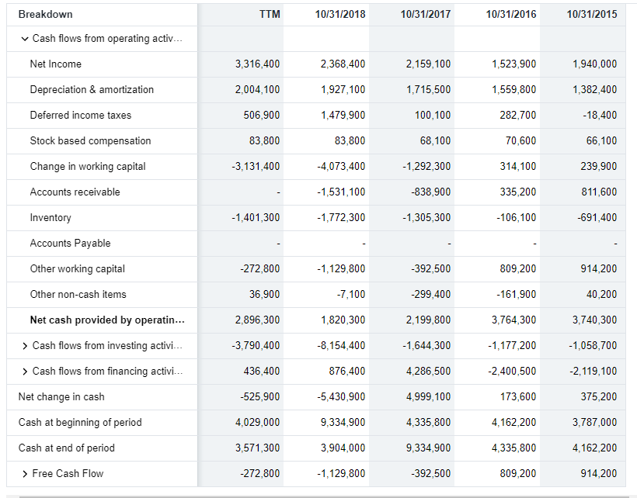

John Deer: Income Statement
